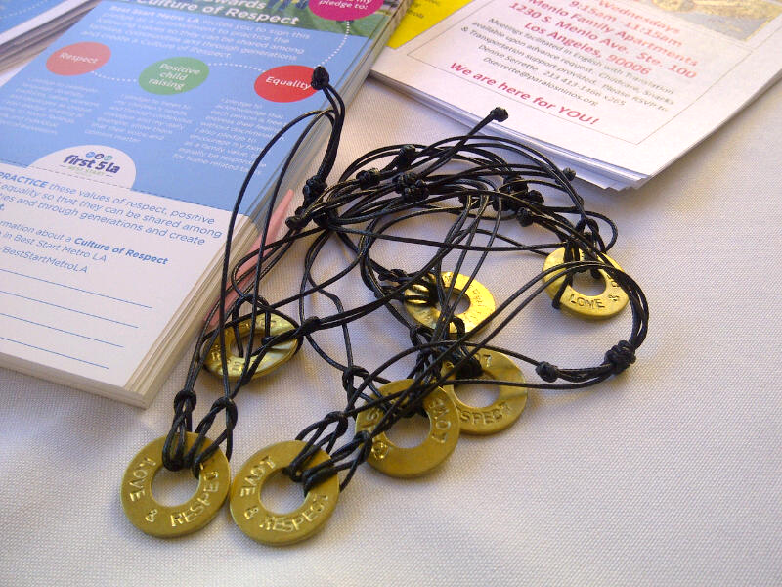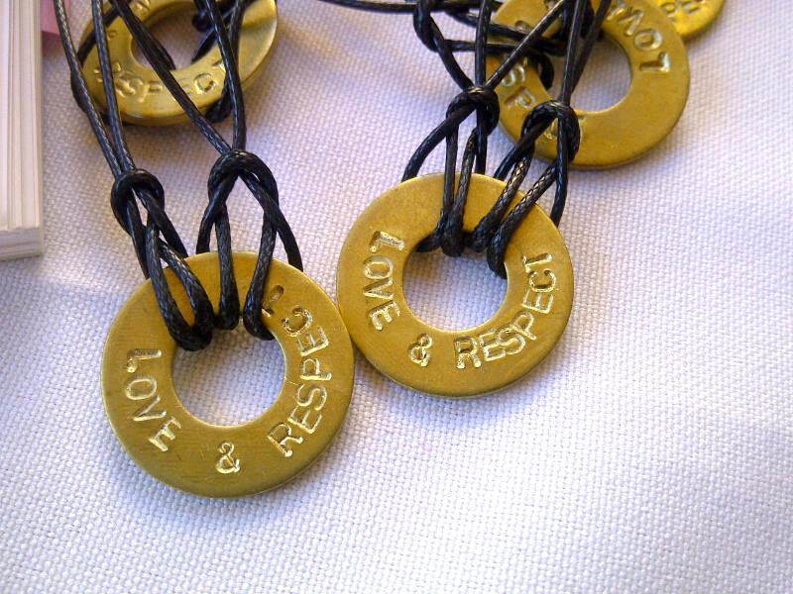
Photos of day of event, Sunday June 19, 2016 12:00-1:30p St. Marks Lutheran Church, Los Angeles

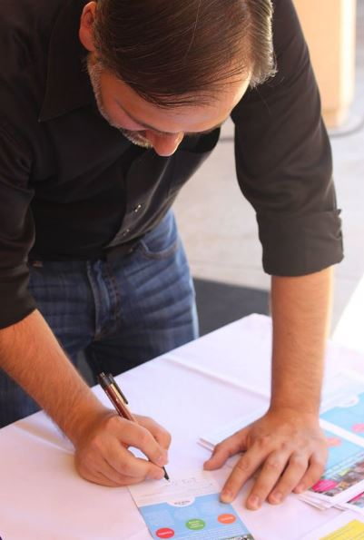
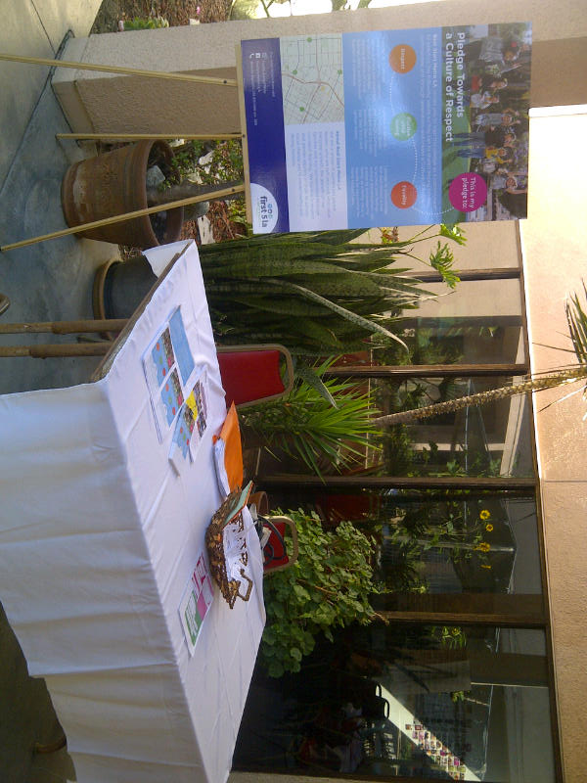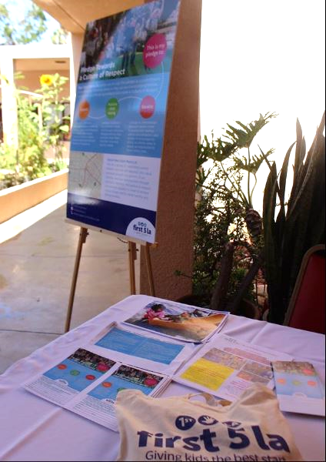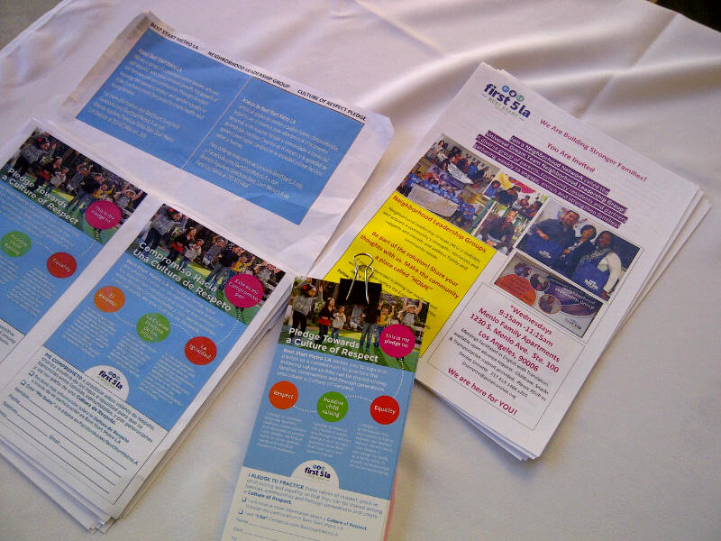 Display table at event.
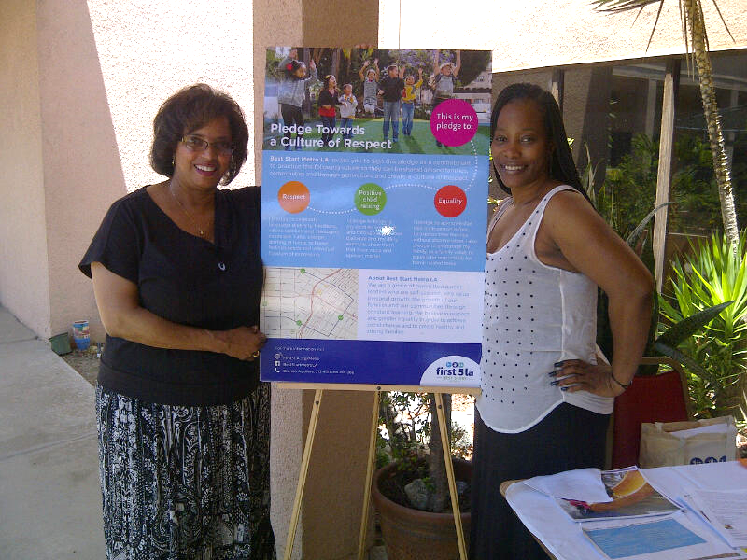
Promotora, Denise Serrette and Universal Dream Team NLG Rep, Talauna Jones

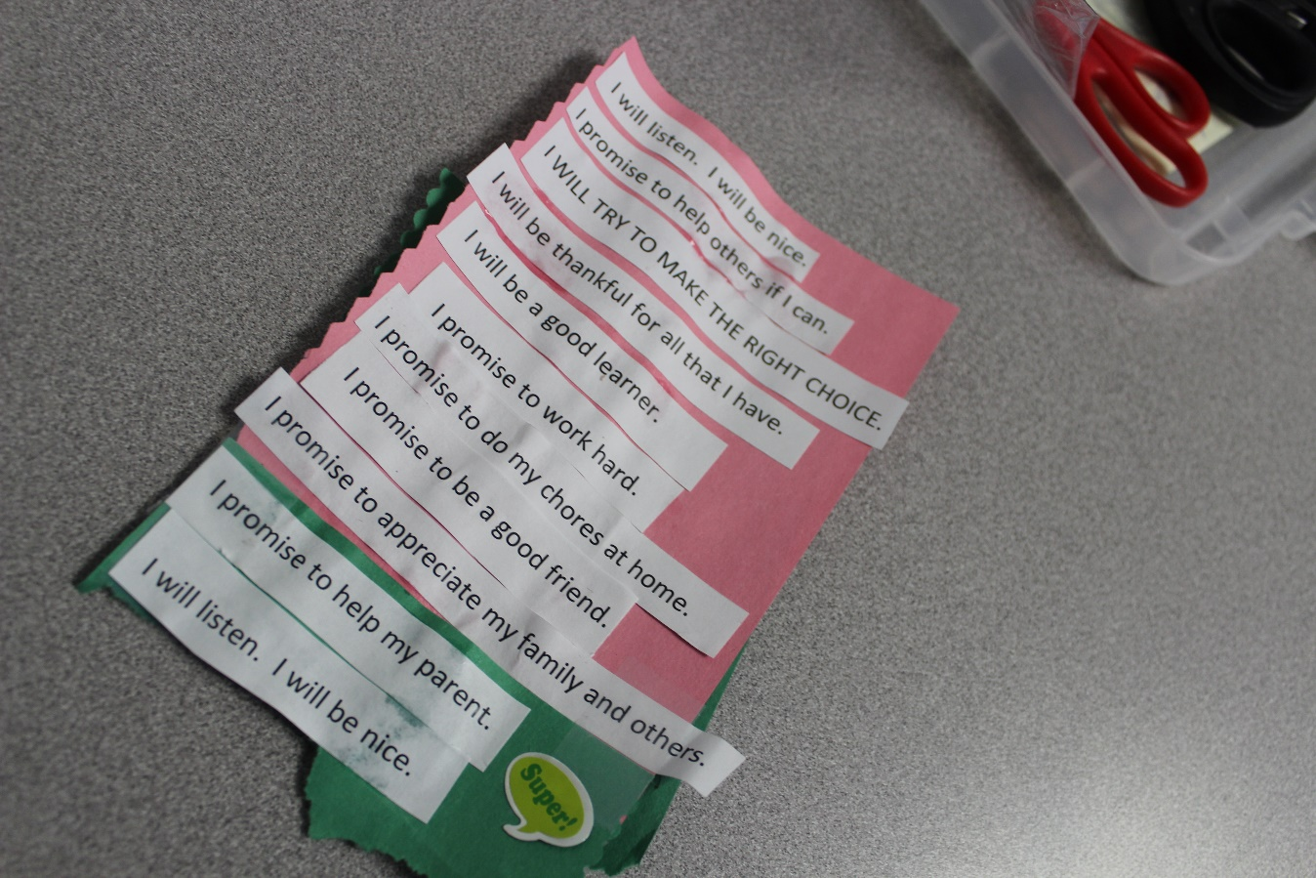
A sample of the youth promises/pledge/personal statement activity.
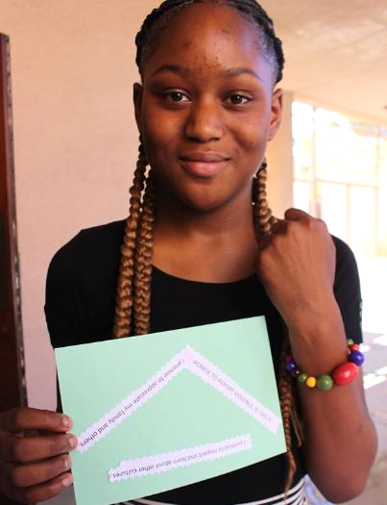\
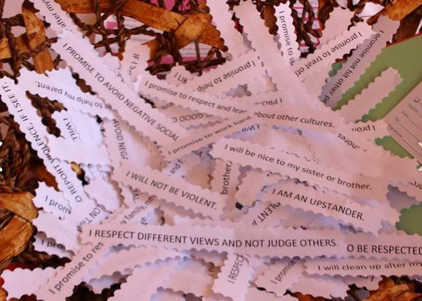
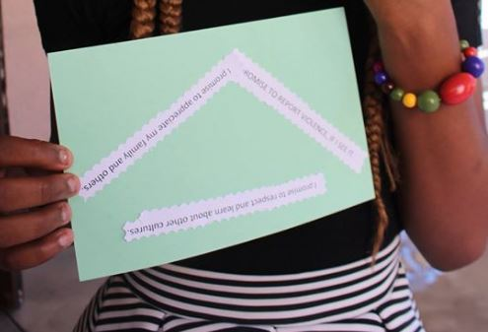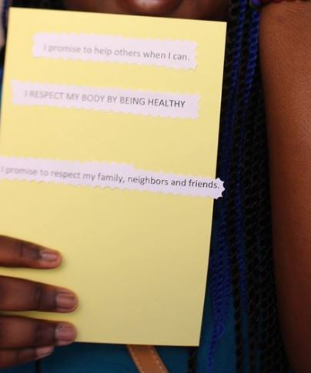
Youth members enjoyed creating their unique personal promise/pledge. They were given beaded bracelets for their participation, since the Culture of Respect Pledge is for intended for Adults.

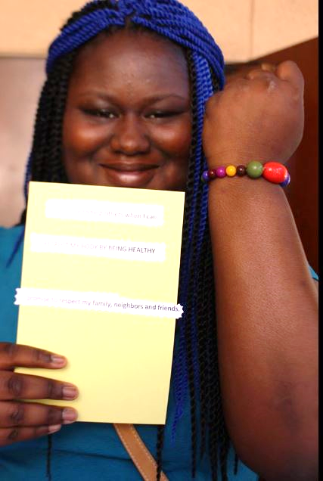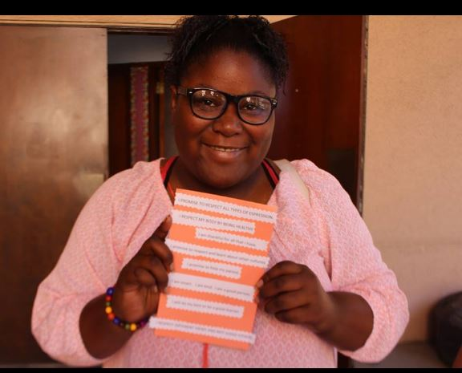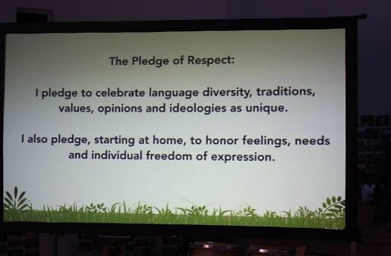
The theme of the Culture of Respect and the pledge was woven into the worship service. Many members stood and recited the pledge in unison.
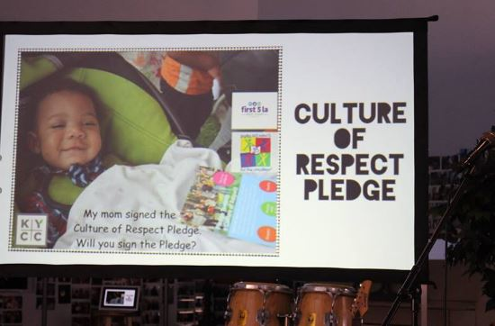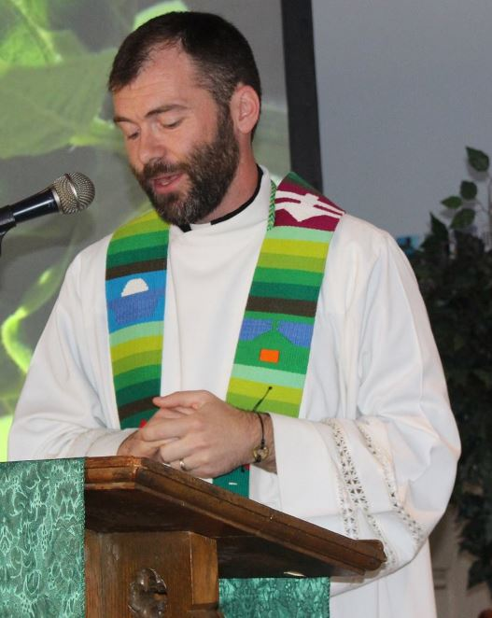 Pastor Matt Keadle, proudly wore his bracelet during his sermon.
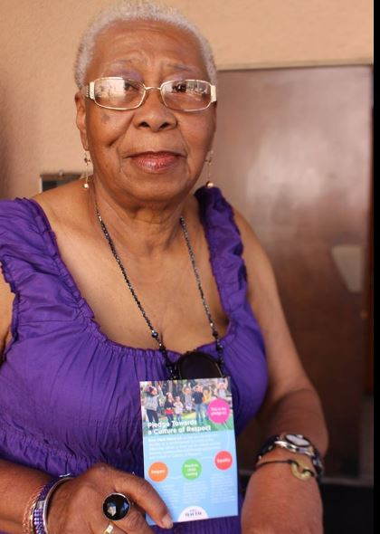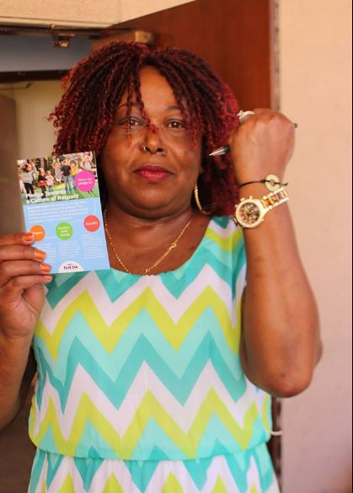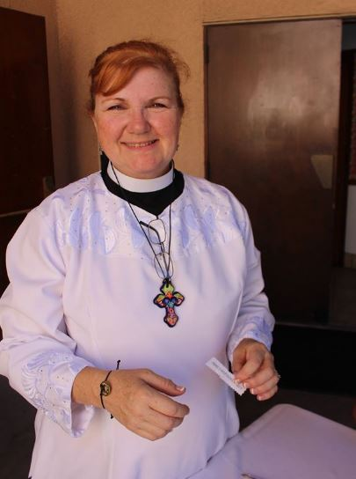
Members of the congregation proudly show their bracelets and pledge cards.

Sharing the Culture of Respect with the Community!
Universal Dream Team
@ St. Mark’s Lutheran Church,
3651 S. Vermont Ave. Los Angeles (Near 36th Place and Vermont Ave., between Jefferson and Exposition, across from USC)

SUNDAY, JUNE 19, 2016
10:00AM – 12:30P*
10:00AM – 11:45AM – Worship Service (optional)
11:45a-12:00p Video Clip & Introduction of NLG Members Present
12:00p – 12:30p Q & A/ Present Pledge and Bracelets to Signers
12:30 – 1:00p until Enjoy Refreshments

