Koreatown Youth and Community Center
Urban Tree Beautification

Attend our Environmental Services volunteer event!

Learn how to maintain trees. Work with our staff certified arborists to beautify and maintain trees that contribute to a greener and healthier Los Angeles.

Get involved in your community. We serve several neighborhoods across Los Angeles including Koreatown, South LA, Pico-Union, Westlake and beyond.

Gain professional experience. Learn more about environmental initiatives in Los Angeles and network with other community groups and people.

Have fun! Meet new people and make a difference that is empowering and rewarding.
When?
Saturday · Jul. 16, 2016 · 9 a.m. – 12 p.m.

Where?
1049 Elden Ave, Los Angeles 90006

Register:
environmental@kyccla.org
http://www.kyccla.org/services/environmental-services/

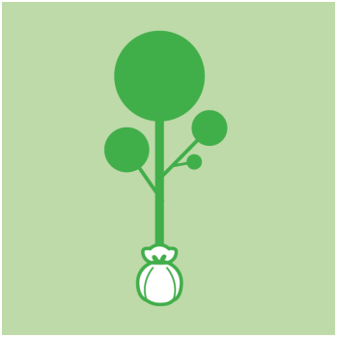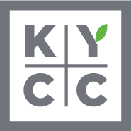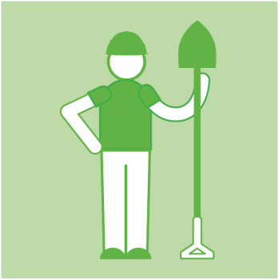

@KYCCLA

